**REPRODUCTION**

***Reproduction is the process by which organisms multiply to increase in number***. This is important in maintaining the life of organisms from one generation to another.

**Types of reproduction**

There are two types of reproduction.

1. Asexual reproduction
2. Sexual reproduction.

**ASEXUAL REPRODUCTION**

***This is a type of reproduction, which does not involve fusion of gametes, and therefore only one individual is involved***. This type of reproduction takes several forms, which include the following.

1. **Budding.**

This is a mode of asexual reproduction in which an organism develops an outgrowth (bud), which detaches its self from the parent organism and starts to grow as a self-reliant organism. It is common in yeast and hydra.

1. **Spore formation**

This is a mode of asexual reproduction, which involves production of spores. Spores are microscopic structures, which can be dispersed and have the ability to germinate into a new organism under favorable conditions. This mode of reproduction is common in fungi and some bacteria.

1. **Fragmentation**

This is a mode of asexual reproduction where an organism breaks into many small parts (fragments) and each is able to grow into a new individual. It is common in tapeworms and spirogyra.

1. **Binary fission**

This is a mode of asexual reproduction where a single celled organism divides up into two parts, which start to grow as separate individuals. It is common in amoeba and other protozoans

***Question:***

*Describe the process of asexual reproduction in;*

1. *Amoeba*
2. *Rhizopus*
3. *Yeast*
4. *Spirogyra*
5. **Multiple fission**

This is a mode of asexual reproduction where a single celled organism divides into many parts, which grow into separate individuals. This occurs in plasmodium.

1. **Vegetative reproduction**

This is a mode of reproduction in plants where part of the plant other than the seeds develops into a new individual. This normally takes many forms, which include rhizomes, bulbs, corms, suckers, stolons, runners etc

**Table showing various types of vegetative propagation**

|  |  |  |
| --- | --- | --- |
| **Name** | **Characteristics** | **Examples** |
| Rhizome | Underground stem, swollen with food, has lateral buds, has scale leaves, has nodes and internodes. | Ginger, cana lily |
| Stolon | Underground stem, not swollen with food, has lateral buds, has scale leaves. | Couch grass, spear grass |
| Runners | Grows on the surface, has fibrous roots, has lateral buds, has scale leaves, has nodes and internodes. | Star grass |
| Bulbs | Leaves swollen with food, has a short stem, has adventitious roots, has scale leaves, has thick foliage leaves, has lateral buds. | Onions, garlic |
| Corms | Vertical stem swollen with food, has adventitious roots, has lateral buds, has scale leaves. | Yams |
| Suckers | New individual plant produced alongside the parent plant | Pineapple, banana |

**Advantages of vegetative reproduction**

* New plants resemble the parent plant and any good quality in the parent is retained.
* The growth of the new plant is rapid.
* The reproductive organ stores plenty of food which the new plant uses.
* It does not involve processes like pollination, fertilization and dispersal agents are not required.
* Large areas can be covered in relatively little time.
* It involved only one individual.

**Disadvantages**

* Since new plant grows on its parent, it can lead to crowding.
* Shortage of water and mineral salts is likely to occur due to competition.
* Diseases of the parent plant can be transmitted to the young ones.
* If the parent plant has poor characters, they can be maintained by the young ones.

**ARTIFICIAL VEGETATIVE PROPAGATION**

This is a mode of reproduction where man is involved in the propagation process. It is done in several ways, which include, budding, grafting, layering, cuttings, etc.

1. **Budding**

This is the process where a bud is detarched from a plant and grown in suitable conditions into a new plant.

1. **Grafting**

This is the insertion of part of one plant onto another plant so as to come into organic union and to grow as one plant. The part inserted can be a bud or a shoot of a plant and it is called a **scion**. The part in the ground on which the scion is inserted is called a **stolk**. The scion and stolk should be of different varieties but same species.

1. **Layering**

This is where a branch of a plant is bent to touch the ground and allowed to develop roots. When the roots are developed, it is cut from the plant and it starts to grow as a separate self-supporting plant.

**Advantages of asexual reproduction**

1. It is reliable because it is less likely to be affected by adverse environmental factors like for the case of seeds.
2. It leads to genetic consistence since there is no mixing of genes during reproduction.
3. It results into early maturity because the organisms produced have enough food reserve from the parent.
4. It is self-sufficient because it does not rely on external processes like pollination, fertilization and dispersal.
5. It does not result in indiscriminate and wide spread distribution like in the case of seeds, which leads to wastage.
6. It does not require formation of sex organs.
7. It is the only means of reproduction in some organisms.

**Disadvantages of asexual reproduction**

1. It leads to maintenance of bad characters.
2. It does not introduce variations in the offspring since there is no gene mixing.
3. It easily results into competition between offspring due to overcrowding.
4. It gradually results into reduction of the strength and vigour of the succeeding generations.
5. There is a high chance of disease transmission from parent to offspring.

**SEXUAL REPRODUCTION**

This is a type of reproduction which involves the fusion of male and female gametes to form a zygote.

**SEXUAL REPRODUCTION IN NON FLOWERING PLANTS**

**Reproduction in spirogyra**

Spirogyra is a green non flowering plant belonging to a group of plants known as algae. The main type of sexual reproduction in spirogyra is conjugation.

1. The opposite cells of the two different filaments lying side by side develop a swelling or an out-growth which begins to grow towards each other.
2. On touching they dissolve to form a conjugation tube and at the same time the contents change into gametes.
3. The gametes from one cell (male gamete) migrate through the conjugation tube to another cell (female) gamete.
4. The two gametes fuse to form a zygote which develops a thick resistant wall and becomes a zygospore.
5. When the conditions are favorable, the zygospore germinates and grows into another filament.

Illustration

cell wall breaks down

spore

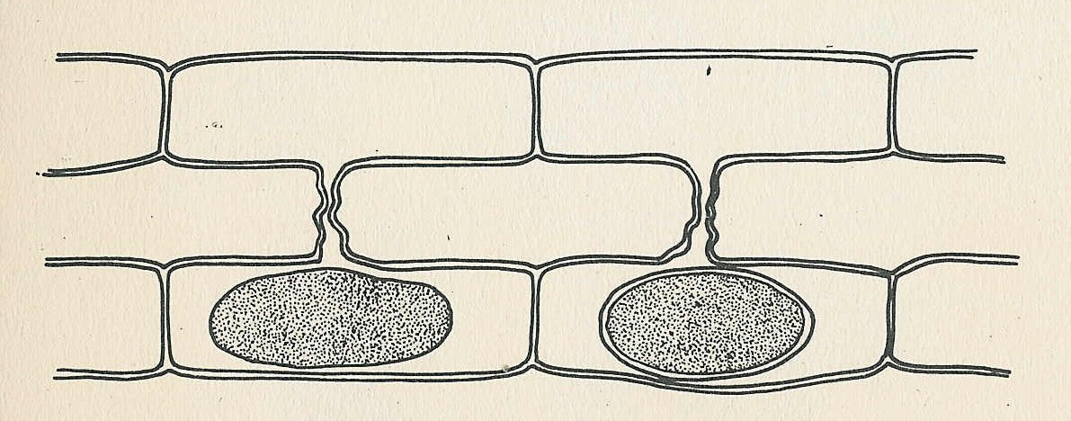

© D.G. Mackean

When conditions improve, the spore germinates to produce a new filament

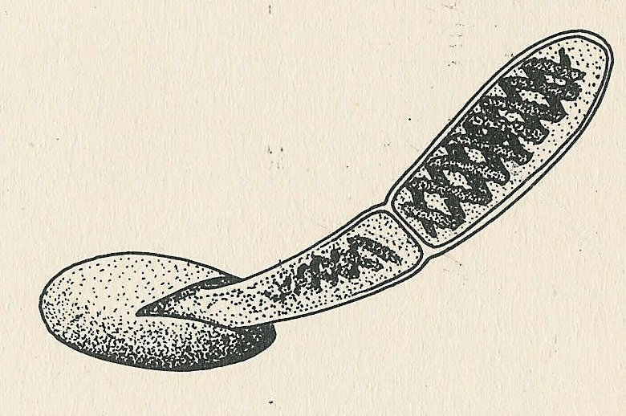

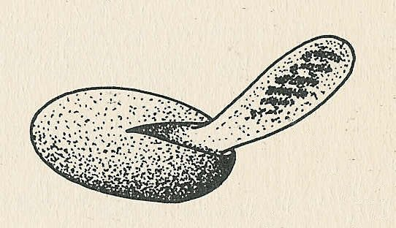

The zygote forms a wall round itself and becomes a spore which can resist

adverse conditions, e.g. cold and lack of light.

**Sexual reproduction in fungi (Rhizopus) E.g. mucor**

1. The tips of the two hyphae of different mycelia become swollen and grow towards each other until they touch. The two opposite swellings are referred to as positive and negative hyphae.
2. The swellings are cut off from the rest of the mycelia by a cross wall, nuclear division takes place and each swelling contains several nuclei.
3. When they touch, the wall dissolves and nuclei fuse in pairs. The thick outer cover forms around them to form a zygospore. This remains dormant for as long as conditions are unfavorable but germinate if the conditions are favorable.

Diagram to show sexual reproduction in rhizopus

-

+

Two hyphae of different mating type come together

The hyphae fuse and their contents mix to form a zygote

A thick wall develops around the zygote to form a zygospore

Under favorable conditions the zygosppore germinates to produce new mycelia

**SEXUAL REPRODUCTION IN FLOWERING PLANTS**

In flowering plants the flower is the reproductive organ.

The male gametes are the male nuclei found in the pollen grains produced by the anthers.

The female gametes are the egg nucleus and polar nuclei found inside the ovules located in the ovary. These two are brought together shortly after pollination.

**POLLINATION**

Pollination is the transfer of pollen grains from the anther of a flower to the stigma of the same flower or different flowers of the same species.

Pollination is of two types;

* Self-pollination
* Cross pollination

**Self-pollination**; is the transfer of pollen grain from anther of a flower to the stigma of the same flower.

**Cross pollination**; is the transfer of pollen grain from anther of a flower to the stigma of another flower of the same species. Flower may or may not be from the same plant.

**Features that promote cross pollination**

* Brightly colored petals.
* They have a nice scent to attract insects.
* Produce nectar which is food source for the insects.
* Stamen produce sticky pollen grains which adhere firmly to the bodies of visiting insects.
* The stigma are flat, lobbed and have sticky surface to which pollen grain can easily adhere.
* Presence of landing plat form and pollen guide which ensures that insects visit the flower.
* Stamen hanging outside the corolla to ensure that pollen grains are blown away by wind to another flower.

**Characteristics of wind pollinated flowers**

* Usually not brightly colored
* Not scented and lack nectar.
* Stamen of wind pollinated flowers produce large quantity of light powdery pollen grains.
* Usually small and inconspicuous but are borne in large inflorescences.
* The stigma are large often feathery and hang outside the flower by long styles. This provides a large surface area on which pollen grains floating in the air may be trapped.

***Arrangements that promote self-fertilization (arrangements preventing cross pollination)***

1. Maturation of both male and female parts of the flower at the same time.
2. Flowers borne underground.
3. Flowers being bi-sexual.
4. Flowers remaining closed.

***Arrangements that promote cross pollination (arrangements preventing self-pollination)***

1. Possession of unisexual flowers such that both sexes appear on different plants (dioecious). E.g. in pawpaw
2. Self-sterility in monoecious plants like maize.
3. **Dichogamy,** a condition in which the stamens and pistils do not ripen at the same time. This results in failure of cross fertilization. If the stamens ripen before the pistil the condition is referred to as **protandry** while if the pistil ripens before the stamens it is called **protogyny.**
4. Stigmas being higher than anthers.

Differences between wind pollinated and insect pollinated flowers.

|  |  |
| --- | --- |
| **Wind pollinated** | **Insect pollinated** |
| 1. Produce light pollen grains | Produce relatively large and heavier pollen grains. |
| 1. They produce large quantities of pollen grains | Produce small quantities of pollen grains. |
| 1. They are usually not scented | They are scented. |
| 1. Petals are dull colored. | Petals are brightly colored. |

N.B:

Self-pollination has the disadvantage of failing to introduce variation in the new generation. This results into maintenance of poor characters from one generation to the next.

Cross pollination results into mixing of genetic material which leads to variation. This results into introduction of new character from one generation to the next.

**FERTILIZATION IN PLANTS**

This is thefusion of male and female gamete to form a zygote. Fertilization in plants is internal taking place inside the ovary in the structure called embryosac.

**The process of fertilization in plants:**

1. Pollen grain lands on the stigma of a flower of the same species.
2. On the stigma, pollen grain absorbs water, nutrients and then germinates to form a pollen tube which grows through the style under the control of the tube nucleus at the tip.
3. Pollen grain has two nuclei i.e. generative nucleus and pollen tube nucleus. The generative nucleus divides mitotically to form two male nuclei which lie behind the pollen tube nucleus.

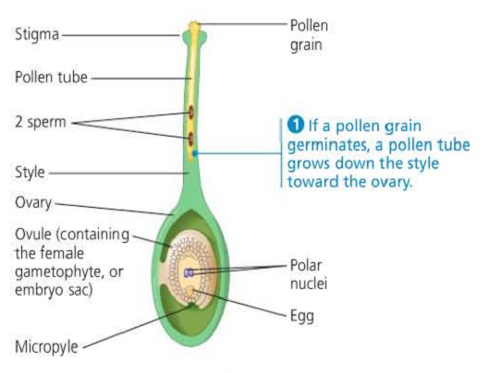

1. The pollen tube enters the ovary and the tip of the pollen tube breaks. The pollen tube nucleus disappears.

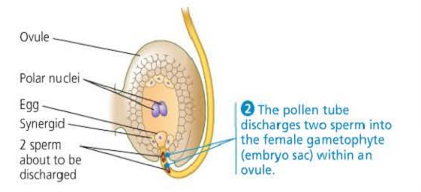

1. One of the male nucleus fuse with the egg nucleus to form a zygote which divides mitotically to form embryo.
2. The other male nucleus fuses with two polar nuclei to form a triploid endosperm which develops into endosperm. This is called double fertilization.

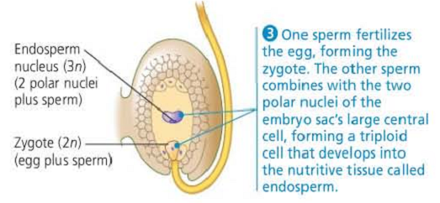

**Events after fertilization**

1. The zygote divides mitotically followed by growth and development resulting into an embryo.
2. The triploid endosperm divides mitotically to form good solid organs called endosperm.
3. The ovules develop into seeds.
4. The integuments become the seed coat.
5. The ovary develops into a fruit and ovary wall develops into a fruit wall which protects the seeds.
6. Petals, stigma, style and stamen wither and fall off while the calyx may wither and fall off or may remain in shriveled form.

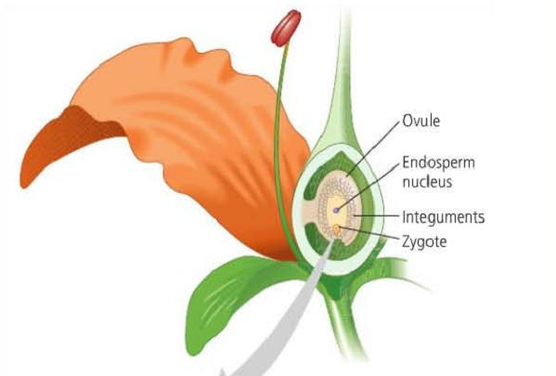

**REPRODUCTION IN ANIMALS**

Sexual reproduction is the only form of reproduction in vertebrates and few invertebrates. E.g. Arthropods.

For this reason, most of animals have reproductive organs in which the gametes are produced. To adopt various conditions in the habitat in which they live different animals show different forms of fertilization and development.

**Reproduction in insects**

Insects show internal fertilization and external development with complete and incomplete metamorphosis.

**Metamorphosis:**

This is the developmental change from the eggs to the adult stage in the life cycle of an organism. It is divided into two, i.e. complete and incomplete metamorphosis.

1. **Complete metamorphosis**

This is the type of metamorphosis where eggs hatch into larvae, pupa then to adult. It occurs in houseflies, butterflies and moths. Insects which show complete metamorphosis are called holometabolous insects.

1. **Incomplete metamorphosis**

This is the type of metamorphosis where eggs hatch into nymph that resembles the adult except that it lacks wings, smaller than the adult and sexually immature. It occurs in insects such as cockroaches, grass hoppers and locusts. Insects which show incomplete metamorphosis are known as hemimetabolous insects.

**Sexual reproduction in Bony fish**

Like Tilapia, show external fertilization and external development beginning with laying of large quantities of eggs. Mating may follow courtship in some species and the eggs after hatching may get minimum parental care in form of protection from enemies.

**Sexual reproduction in amphibians**

They show external fertilization and external development. There is some protection offered to the eggs by a jelly but there is lack of parental care to the tad poles.

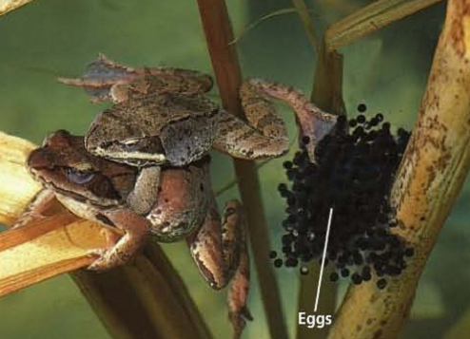

**Sexual reproduction in birds**

Birds show internal fertilization and external development. Prior or before fertilization most birds show courtship behavior, nest building and development begins with laying of eggs which hatches into young ones.

Courtship stimulates the female sexually to a point (nest) where the male bird is;

* On mating, the male presses his cloaca directly against the female’s cloaca and sperms are released directly into the oviduct through the cloaca.
* The sperms swim up to the oviduct until they come into contact with the eggs without shell. Here internal fertilization takes place.
* The fertilized eggs pass to the oviduct where they release albumen and a hard protective shell.
* The eggs are laid in the nest and incubation starts after all the eggs are laid.

**Structure of the egg.**

Shell

Shell membrane

Air space

Albumen

Egg membrane

Chalaza

Yolk

(Germinal disc) Area, which develops into the embryo

**Parts of the egg**

1. **Shell**; this protects the egg and prevents it from desiccation.
2. **Airspace**; this stores air for gaseous exchange of the embryo.
3. **Charaza**; this holds the yolk in position.
4. **Albumen;** this is a source of proteins and fats to the embryo.
5. **Germinal disc**; this develops into an embryo.
6. **Yolk;** this stores food for and surrounds the embryo.

**Development:**

The living cells in the egg divide to make the tissues and organs of the young birds. The yolk provides the food for this development. The albumen is the source of proteins and water. The shell and shell membrane are permeable to air. Oxygen diffuses into the airspaces and is absorbed through the blood capillaries of the embryo. The blood carries oxygen to embryo and Carbon dioxide is eliminated through the egg shell by the reverse process. When the chick is fully developed, it breaks out of the shell by help of its beak during hatching.

**Incubation:**

The female bird is responsible for incubation of the eggs. The function of incubation is to provide the optimum temperature for the embryo’s development in the egg. The incubation period differs from one species of birds to another.

**Differences between internal fertilization and external fertilization**

|  |  |
| --- | --- |
| **External fertilization** | **Internal fertilization** |
| Water as an external factor is necessary | Water as an external factor is not necessary |
| A lot of gametes are produced and necessary | Less gametes are involved in the process |
| Embryos develop not well protected and mostly helpless after birth | Embryos develop well protected and normally offered help after birth |
| A lot of energy is involved since more gametes are produced. | Less energy is involved since fewer gametes are produced |
| Chances of fertilization occurring are fewer | Chances of fertilization are higher |

*N: B the above points can serve as advantages of internal over external fertilization*.

**SEXUAL REPRODUCTION IN MAMMALS**

Mammals reproduce sexually. They have special reproductive organs that produce the gametes i.e. sperms and ovum.

**THE MALE REPRODUCTIVE SYSTEM**

It consists of the testis, epididymis, seminal vesicles, prostate gland, Cowper’s gland and penis.

**Vertical section through the male urino-genital system**

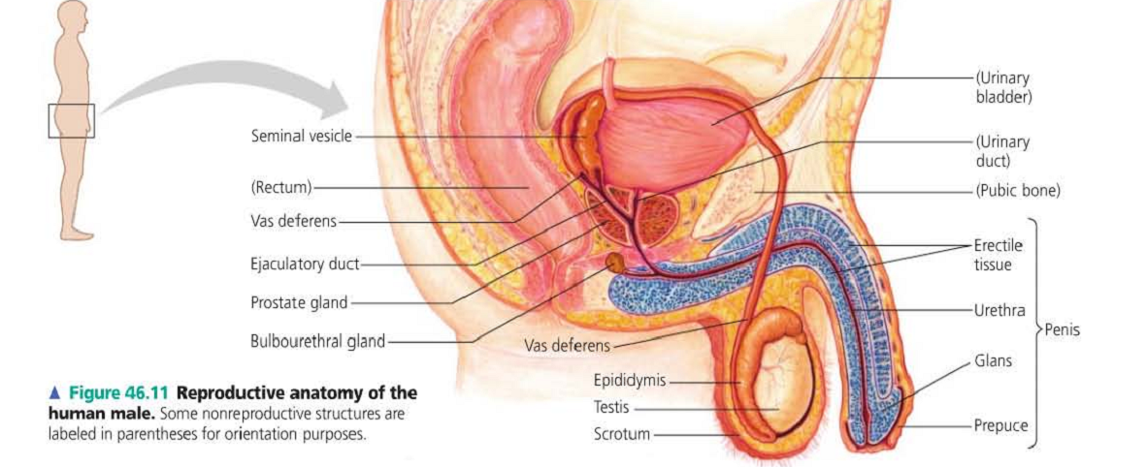

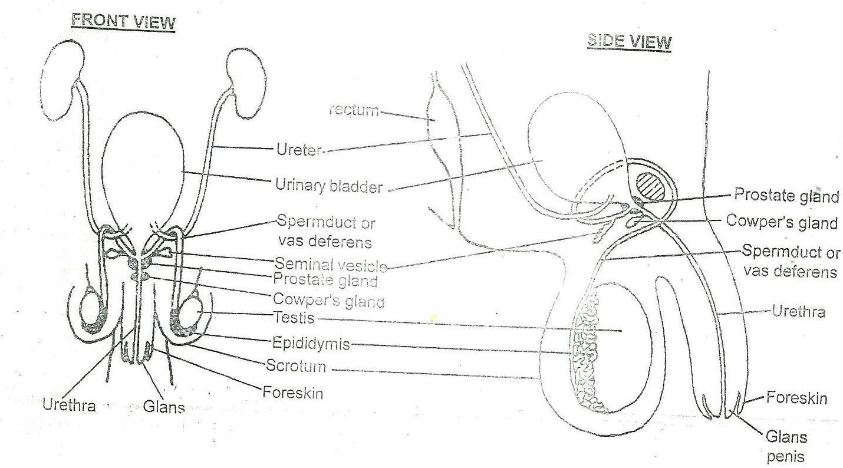

**Functions of the parts:**

1. **Seminal vesicle;** secrets viscous fluid-containing fructose which acts as a nutrient for sperm cells.
2. **Prostate gland;** this gland secretes an alkaline, milky-white fluid that neutralizes the acidity of the Vagina.
3. **Penis;** delivers sperms into the female reproductive organ.
4. **Testis;** manufactures and store sperms.
5. **Scrotal sac;** protects the testis.
6. **Vas deferens;** conducts sperms from the testis to urethra during ejaculation.
7. **Urethra;** passage of sperms and semen during ejaculation.
8. **Cowper’s gland;** produces mucus for lubrication of both the male and female urethra to ease copulation.

**Functions of the male reproductive system**

* Used in the delivery of sperms into the female reproductive organ.
* Production and storage of sperms.
* Secrets male sex hormones e.g. testosterone hormone.

**FEMALE REPRODUCTIVE SYSTEM**

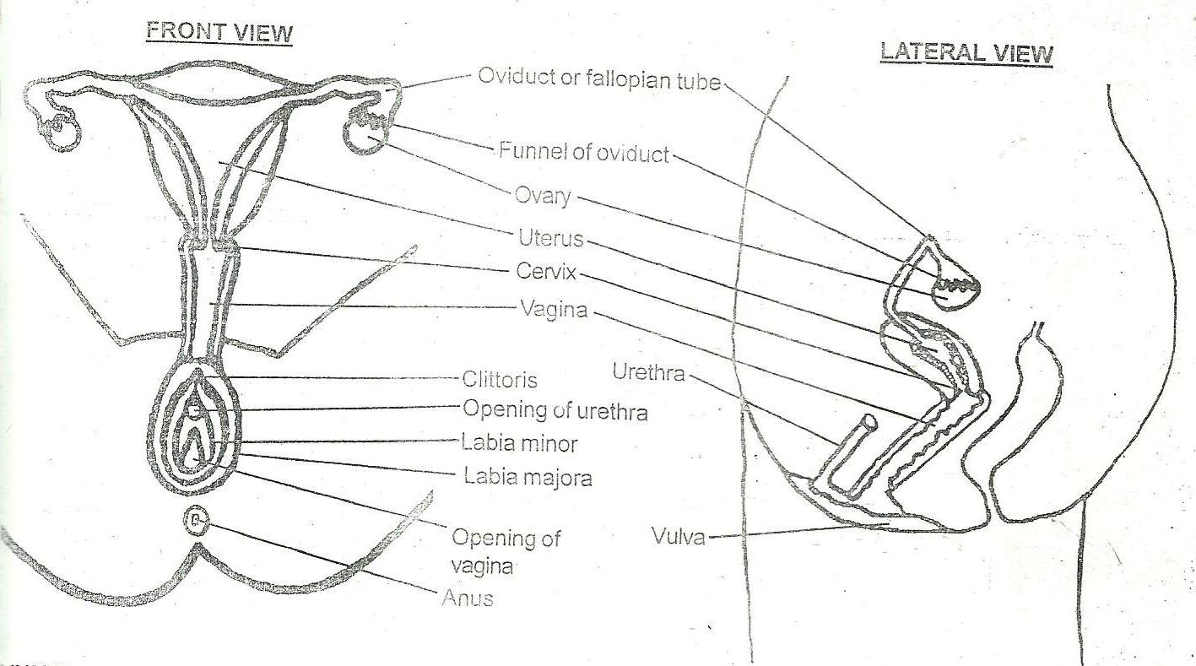

**Function of parts:**

1. **Uterus;** provides suitable environment for growth and development of the fetus. It is also an area for implantation.
2. **Vagina;** it provides the following functions;

* Passage of sperms to the uterus.
* Passage of blood during menstruation.
* Allows passage of the fetus at birth.

1. **Oviduct (fallopian tube);**

* It allows movement of fertilized egg towards the uterus for implantation.
* It provides suitable place for fertilization.

1. **Cervix**; contains elastic muscles which allows its expansion during birth and it is the gate way to the uterus.
2. **Vulva**; This is a collective term for the external genetalia. It is made up of two skin folds that is the inner fold (**labia minora**) and the outer fleshy fold **(labia majora**). Labia minora contains mucus secreting glands which lubricates the vagina during sexual intercourse (copulation).

**Labia majora** cushion the vagina and helps in sexual arousal. In the place where labia majora and **labia minora** meet is a bean-like structure called **clitoris**. This is the most sensitive part, which brings about sexual excitement in females.

1. **Vagina**; This is a muscular tube, which connects the vulva to the uterus. It has an average length of 10cm. It secretes acidic mucus, which prevents growth of bacteria and fungi. The mucus also lubricates the vagina. The vagina plays the following roles.

* It is a passage for menstrual flow.
* It is a birth canal.
* It is where the male inserts his erect penis during sexual intercourse.

**General function of the female urino-genital system**

* Production of the female gametes i.e. the ovum
* Reception of the male gametes i.e. the sperm
* Provision of a suitable environment for fertilization
* Provision of a suitable environment for the fetus development.
* Provision of a means for the expulsion of the developed fetus during birth.
* Secretion of hormones like oestrogen

**GAMETES**

These cannot develop any further until fertilization occurs. There are two types of gametes namely; male and female gametes also known as sperm cells and ova (singular; ovum or egg cell) respectively. Both male and female gametes are haploid.

**The structure of a sperm cell (male gamete)**

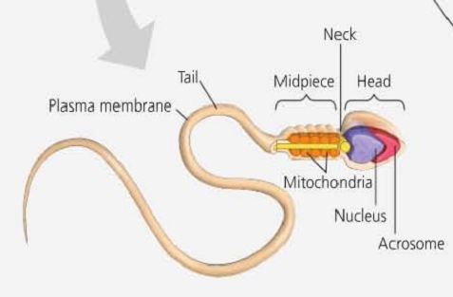

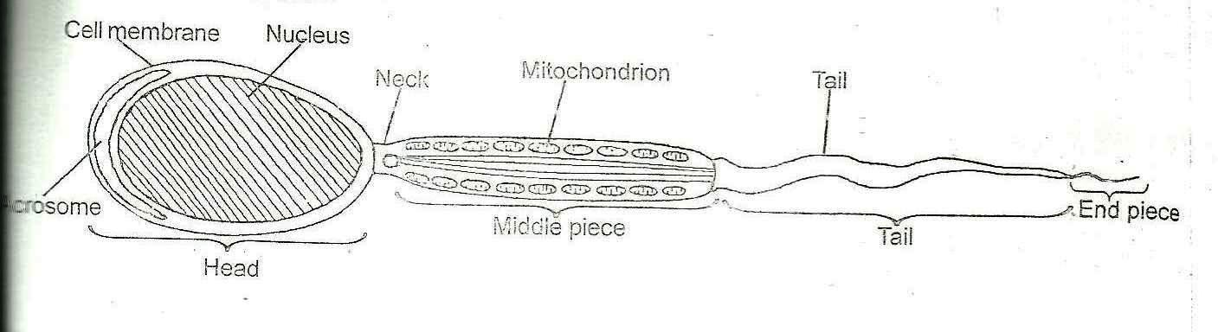

**The structure of the ovum**

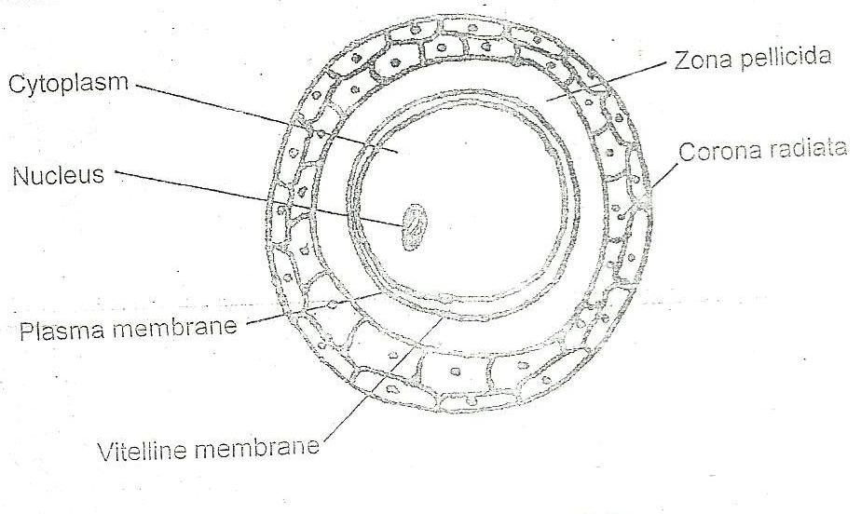

**Functions of the parts:**

1. **Acrosome;** contains juice together with enzymes which dissolve the egg membrane (Vitelline) to bring about fertilization.
2. **Nucleus;** contains genetic material which is responsible for transmission of characters from the parent to the off spring.
3. **Middle piece;** contains mitochondria which provides energy required for the movement of the sperm.
4. **Tail;** propels the sperm forward as it swims towards the ovum.
5. **Neck;** connects the head and tail of the sperm.
6. **Cytoplasm;** it acts as a food store for the embryo.
7. **Vitelline;**

* It provides protection to the inner part of the egg.
* Allows exchange of materials around the egg and its surrounding.

**Differences between sperm and ovum**

|  |  |
| --- | --- |
| **Sperm cell** | **ovum** |
| Has a tail | It is spherical and has no tail |
| It is very small | It is big |
| Has less food store | It has more food store |
| It is mobile | It is immobile |
| It has either X and Y chromosomes (XY) | It has only X chromosomes (XX) |

**FERTILIZATION IN MAN**

Fertilization in man occurs after copulation where erect penis is inserted into the vagina. At orgasm, the penis releases large number of sperms (200-300 millions) near the cervix. The cervix relaxes and opens as sperms swim through its opening to the uterus then to the oviduct where fertilization takes place.

When a sperm get into contact with the egg membrane, it releases enzymes from acrosome which breaks the egg membrane and enable the sperm cell penetrate into the cytoplasm of the ovum.

When the sperm cell enters, the egg membrane becomes thickened to form the fertilization membrane which serves as a barrier preventing the entry of other sperm cells.

The nuclear membrane of the two gametes breaks down and male nucleus fuse with a female nucleus to form a fertilized egg. This process is known as fertilization and the female is said to have conceived.

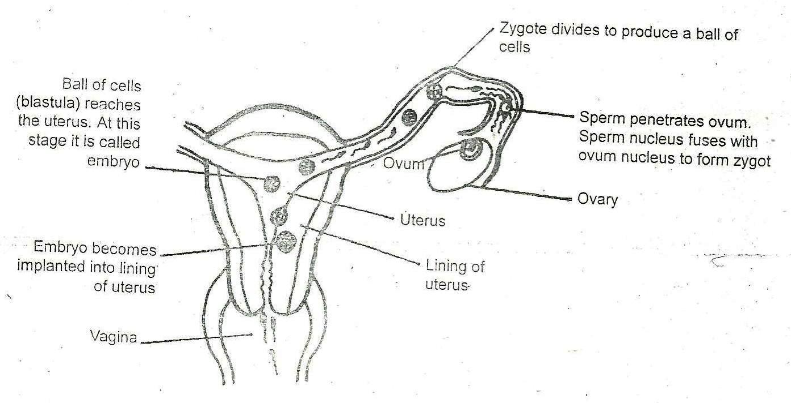

**PREGNANCY**

Gestation is the period from fertilization of an ovum to birth. After fertilization, the under goes cell division by mitosis and move down to the uterus. Its movement is aided by constriction of the oviduct and it takes about one week. Finally the fertilized egg (zygote) is embedded in the lining of the uterus a process known as implantation and it continues with its development.

The fertilized egg now becomes known as the fetus. Later, finger like connections develop between the fetus and the mother’s blood system. This later unites to form placenta connected to the fetus by umbilical cord.

**Diagram showing blood circulation to and from the fetus**

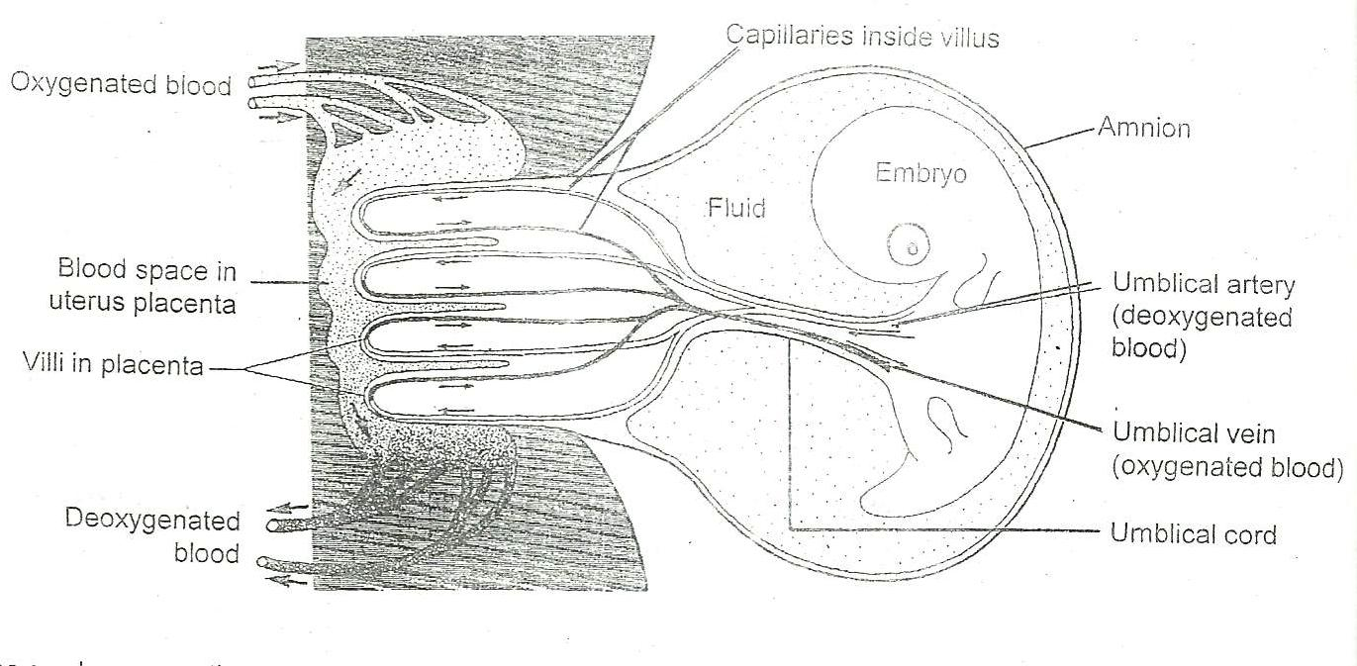

Or summarized as below

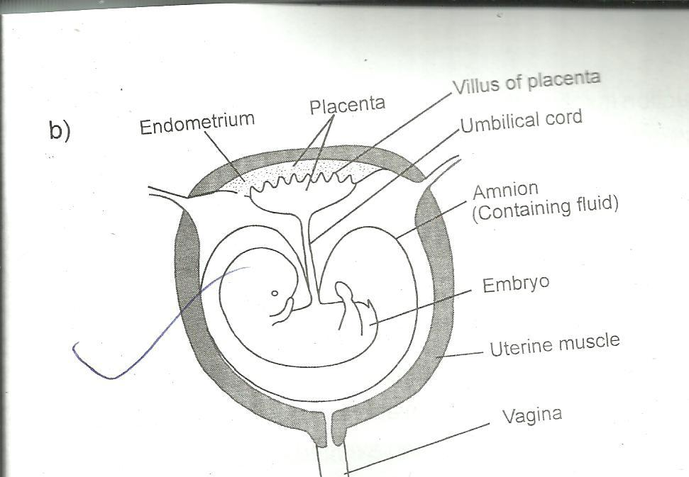

Maternal deoxygenated blood

Embryo

Umbilical cord

Umbilical vein

Capillary network in placenta

Maternal oxygenated blood

Uterus wall

Umbilical artery

**Major nutrients needed by a pregnant mother**

1. Calcium and Phosphates. These are needed for the development of bones and cartilage of foetus.
2. Iron needed for the formation of foetal red blood cells
3. Proteins needed for the formation of new tissue.
4. Vitamins needed for proper growth.

**Functions of the placenta**

1. It allows exchange of materials without the mother’s blood mixing with that of the fetus.
2. It allows transfer of oxygen, water, glucose, amino acids and other substances into the fetus which are used as nutrients.
3. Carbon dioxide, urea and other wastes are transferred from blood circulatory system of the fetus to the mother’s blood across the placenta.
4. It protects the fetus by preventing certain toxins and foreign materials from crossing to the fetus.
5. It acts as a barrier to mother’s hormones and some other chemicals which may affect the fetus.
6. It allows anti bodies to pass onto the fetus there by providing immunity against diseases.

**Nutrition of the fetus**

Soluble food substances, oxygen, water and mineral salt passes across the placenta by either diffusion or active transport from the mother’s blood to the fetal blood through the umbilical vein. Waste products such as carbon dioxide and nitrogenous wastes are brought in to the placenta by umbilical artery where they are passed into mother’s blood. The placenta is therefore the excretory organ of the fetus as well as respiratory surface and source of nourishment.

**Protection of the fetus**

The fetus is contained in a sac called the amnion which is filled with amniotic fluid. The amniotic fluid protects the fetus from mechanical shock and drying.

The fetus is warmed by blood temperature all the time and regulated by mother’s blood.

The placenta prevents passage of bacteria, other foreign materials, nervous transmissions and maternal blood pressure from affecting fetal circulation and also it keeps out toxins from the fetus.

**BIRTH (PARTURITION)**

The embryo turns head down wards in the uterus a few days before birth which occurs at approximately 9 months after fertilization. At time of birth, the uterus contracts rhythmically.

The opening of the cervix dilates (relax) to allow the young’s head to pass through. The amniotic fluid passes out through the vagina.

The contraction of the uterus pushes the young one through the vagina to the exterior. It takes the 1st breathe of life and usually cries, a sign of changed conditions in its environment. After some time the placenta separates from the uterus and finally expelled as after-birth.

**Differences between sexual and asexual reproduction**

|  |  |
| --- | --- |
| **Sexual reproduction** | **Asexual reproduction** |
| 1. Two parents are involved | Only one parent is involved |
| 1. Needs males and female gametes | Does not need gametes |
| 1. Off springs are not identical | Off springs produced are identical |
| 1. Rate of reproduction is slow | Rate of production is fast |
| 1. Fertilization usually occurs | Fertilization does not occur |
| 1. Usually few off springs are produced | Usually very many off springs are produced |

**MALE HORMONES**

At puberty, the hypothalamus stimulates the anterior part of the pituitary to release two hormones.

1. The **follicle stimulating hormone (F.S.H)** which stimulates sperm production.
2. The **Luteinizing hormone (LH)** also known as the interstitial cell stimulating hormone (ICSH) which stimulates the interstitial cells of the testis to release another hormone **testosterone** which stimulates the development of the male secondary sexual characters.

**Secondary characteristics in man**

* Deepening of the voice
* Growth of pubic hair
* Enlargement of the penis
* Onset of wet dreams
* Growth of beards
* Growth of hair in the arm pits

**Secondary characteristics in females**

* Softening of the voice
* Enlargement of breasts
* Enlargement of hips
* Onset of menstruation
* Enlargement of reproductive organs
* Growth of pubic hair
* Growth of hair in arm pits

**FEMALE HORMONES AND THE MENSTRUAL CYCLE**

When the ovum is released by the ovary, the uterus wall thickens with addition of new layer of cells for the ovum to sink if fertilized. The blood supply also increases at the same time. If the ovum is not fertilized, the new layer of cells breaks down and the unwanted cells, mucus and some blood pass out through the cervix and vagina. This is called menstruation. It takes place once about 28 days, 12-14 days after the release of the ovum.

**The menstrual cycle**

The menstrual cycle is controlled by four hormones of which two are secreted from **the interior lobe of pituitary gland and the other two from the ovaries.** The pituitary gland secretes **Follicle stimulating hormone (FSH) and Luteinizing hormone (LH)** and the ovary secretes **progesterone and oestrogen**. The four hormones are secreted in the following sequences.

FSH Oestrogen LH Progesterone

It is a reproduction cycle occurring in sexually a mature female in absence of pregnancy and involves series of changes in the female reproductive system which is controlled by hormones.

# Follicle stimulating hormone (FSH)

* Causes the development of the graafian follicles in the ovaries.
* It stimulates the ovary to produce oestrogen.

1. **Oestrogen.**

* This stimulates the repair of the uterine wall after menstruation.
* When in high levels, it stimulates the pituitary gland to produce LH
* It inhibits the production of FSH from the pituitary gland.

1. **Luteinizing hormone (LH)**

* This cause ovulation in the middle of the cycle.
* It also stimulates the ovary to produce progesterone from the corpus luteum.

1. **Progesterone**.

* This maintains the uterine lining in preparation for implantation.
* It inhibits production of FSH and LH if its level is high.

This leads to the breakdown of the corpus luteum within 14 days after ovulation and hence stops the production of progesterone.

If the ovum is not fertilized;

1. When production of progesterone stops, the endometrium breaks leading to the flow of blood a process called menstruation.
2. If fertilization occurs, the placenta produces the progesterone which prevents menstruation and maintains pregnancy.

Menstruation stops at around the age of 45 years on average and one is said to have reached menopause. At this stage no more pregnancy is possible.

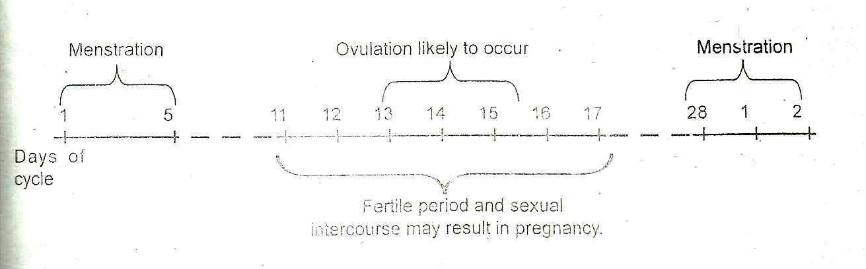

**Graph illustrating the hormonal changes in blood during a menstrual cycle.**

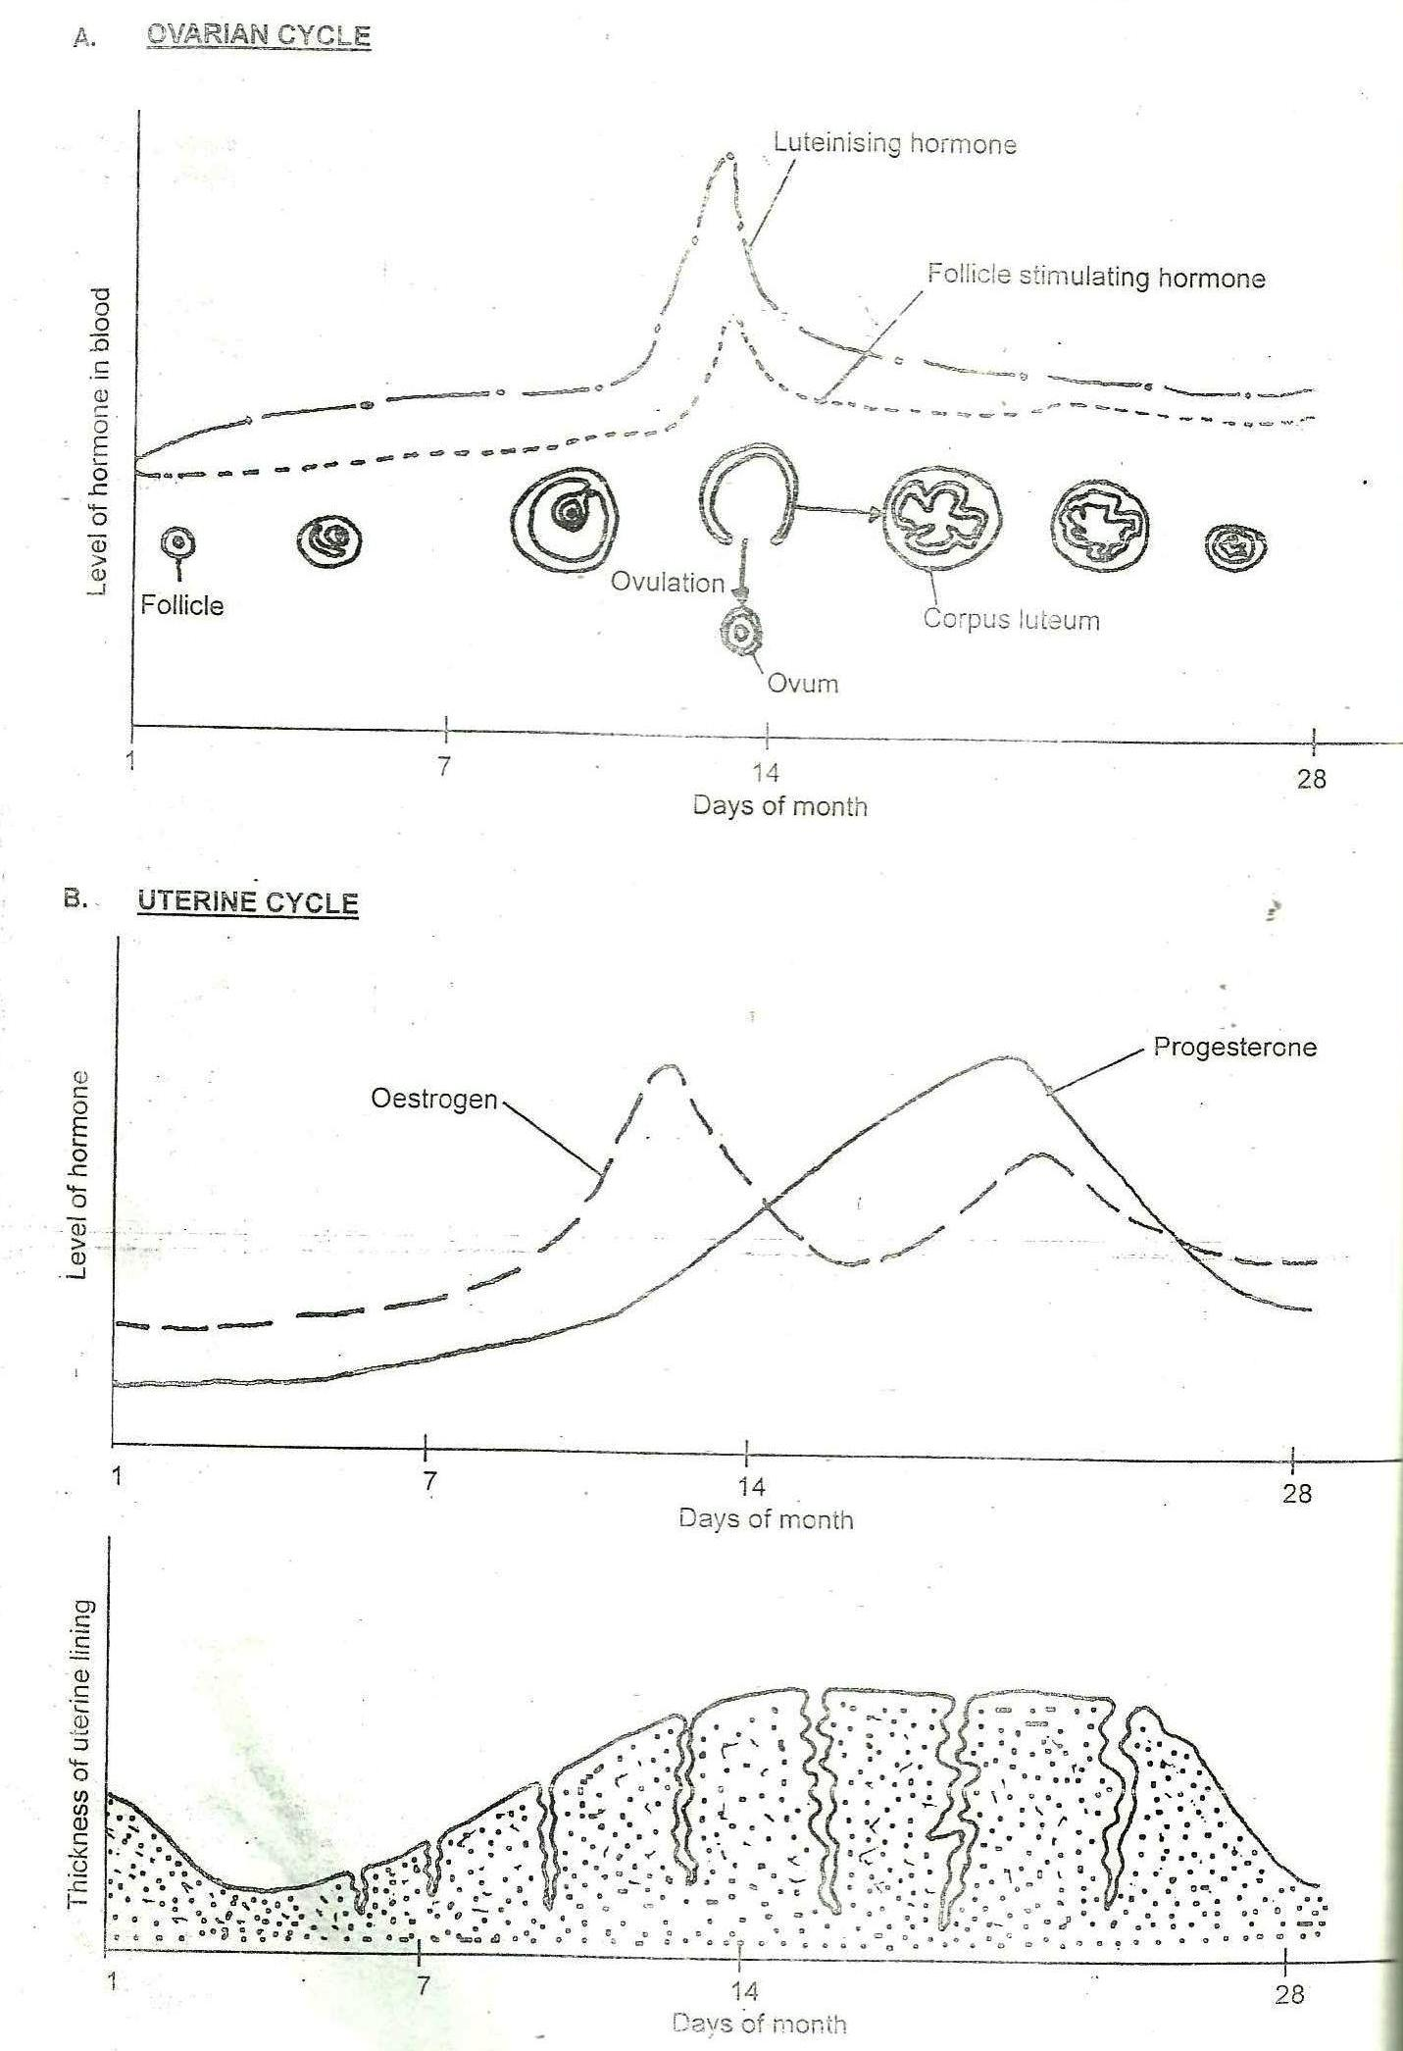

**SAFE PERIODS**

It refers to the days within the menstrual cycle when there in no mature ovum in the reproductive system so a female can have sexual intercourse without getting pregnant.

During the first safe period, there is development of a graphiam follicle and takes about 10 days from the end of menstruation.

A female should obtain for first 2 days before ovulation and 2 days after ovulation because the sperm cannot survive for more than 2 days.

The 2nd safe period starts from around the 18th day up to the 28th day. Thus a mature egg dies after waiting in vain.

**TWINS**

These are two babies produced with in the same time to the same mother as a result of the same pregnancy.

**Types of twins**

1. **Fraternal twins**. These are twins who arise from the fertilization of two ova produced at the same time and fertilized by two different sperms. The babies are not identical but resembles as normal babies in the family. They may or may not be of the same sex.
2. **Identical twins**. These are two babies, who develop from one fertilized ovum that latter divides into two and the two develop as separate individuals. Such babies look alike and are of the same sex

**Multiple births**

These are more than two babies produced to the same mother with in the same time as a result of the same pregnancy.

**METHODS OF BIRTH CONTROL**

1. Coitus interruptus where the penis is withdrawn from the vagina before ejaculation.
2. Rhythmical method where sexual intercourse is avoided at times when ovulation is likely to occur.
3. Use of condoms and diaphragms which prevents sperm from reaching the eggs.
4. Vasectomy where vas deferens are cut by surgical means there by preventing the passage of sperms.
5. Tubal ligation where the fallopian tubes are cut by surgical means there by blocking the passage of the egg.
6. Use of oral contraceptives known as pills, these prevents development of the egg.
7. Use of injectable contraceptives. This is taken every 3 months to prevent ovulation.
8. Intra uterine devices. This prevents fertilized egg from implanting into the uterus.
9. Use of intra-vaginal rings. This ring secretes progesterone like substance which inhibits development of the egg.
10. Use of morning pills which are taken 3 days after sexual intercourse.
11. Abortion which involves termination of viable pregnancies.

***QUESTIONS:***

What is vegetative reproduction in flowering plants?

Define the term menstruation.

Describe the menstrual cycle in females

What are the causes of infertility in males

Describe the process of fertilization in man

Describe the different forms of asexual reproduction in flowering plants.